Assignment 2:

Installing Your Monitoring Service

Student Information

Student Name: BABAJIDE ALUKULUKA

Date (dd/mm/yy): 13th September, 2024

**Step 1 Initial Configuration:**

Complete this section AFTER finishing step 1 of the assignment.

Nagios Installation and Configuration

Linux Distribution Used: UBUNTU

System IP Address:

Current IP Address: 10.0.2.15(Before change)

Static IP Address Based on first name initial from Appendix A (e.g., A = .200, B = .201, etc.)

Static IP Address:10.0.2.201 (After change)

Web Browser Access:

URL: http://10.0.2.201/nagios

Login Credentials Setup: Username; admin password; Jendor321

Tactical Overview Screenshot:

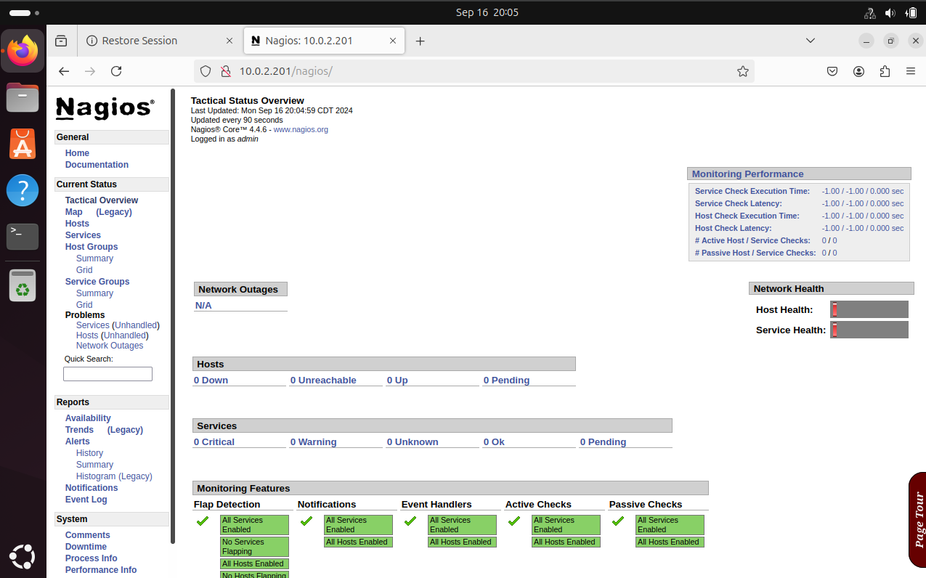

**Part 2: Script and Command Descriptions**

Step 2: Command Interpretation

Script Commands:

**Command:** sudo apt install wget unzip curl openssl build-essential libgd-dev libssl-dev libapache2-mod-php php-gd php apache2 -y  
**Description:** Installs the required packages for Nagios, including utilities like wget, curl, openssl, apache2, and necessary PHP and Apache modules.

**Command:** wget https://assets.nagios.com/downloads/nagioscore/releases/nagios-4.4.6.tar.gz  
**Description:** Downloads the Nagios Core 4.4.6 setup files from the official Nagios website.

**Command:** sudo tar -zxvf nagios-4.4.6.tar.gz  
**Description:** Extracts the downloaded Nagios Core tarball file.

**Command:** cd nagios-4.4.6  
**Description:** Changes the working directory to the Nagios setup folder.

**Command:** sudo ./configure  
**Description:** Runs the configure script to set up the build environment for Nagios Core.

**Command:** sudo make all  
**Description:** Compiles the Nagios Core main program and CGIs (Common Gateway Interface scripts).

**Command:** sudo make install-groups-users  
**Description:** Creates the nagios user and nagcmd group, which will manage Nagios permissions and processes.

**Command:** sudo usermod -a -G nagios www-data  
**Description:** Adds the www-data user (used by Apache) to the nagios group for access to necessary Nagios files.

**Command:** sudo make install  
**Description:** Installs the Nagios Core binaries and supporting files.

**Command:** sudo make install-init  
**Description:** Installs the Nagios Core service initialization scripts, enabling system control of the Nagios service.

**Command:** sudo make install-commandmode  
**Description:** Configures permissions for the directory that contains external commands issued to Nagios.

**Command:** sudo make install-config  
**Description:** Installs the sample Nagios configuration files into /usr/local/nagios/etc.

**Command:** sudo make install-webconf  
**Description:** Installs the Apache configuration file required for running the Nagios web interface.

**Command:** sudo a2enmod rewrite  
**Description:** Enables the Apache rewrite module, which allows URL manipulation.

**Command:** sudo a2enmod cgi  
**Description:** Enables CGI (Common Gateway Interface) in Apache, which is necessary for Nagios.

**Command:** sudo systemctl restart apache2  
**Description:** Restarts the Apache service to apply the configuration changes.

**Command:** sudo htpasswd -c /usr/local/nagios/etc/htpasswd.users admin  
**Description:** Creates an admin user for the Nagios web interface and prompts to set a password. • **Command:** cd ~/  
**Description:** Changes the working directory to the home directory.

**Command:** wget https://nagios-plugins.org/download/nagios-plugins-2.3.3.tar.gz  
**Description:** Downloads the Nagios Plugins version 2.3.3 from the official site.

**Command:** sudo tar -zxvf nagios-plugins-2.3.3.tar.gz  
**Description:** Extracts the downloaded Nagios Plugins tarball file.

**Command:** cd nagios-plugins-2.3.3/  
**Description:** Changes the working directory to the extracted Nagios Plugins folder.

**Command:** sudo ./configure --with-nagios-user=nagios --with-nagios-group=nagios  
**Description:** Configures the build environment for Nagios Plugins, specifying the nagios user and group.

**Command:** sudo make  
**Description:** Compiles the Nagios Plugins.

**Command:** sudo make install  
**Description:** Installs the compiled Nagios Plugins.

**Command:** sudo /usr/local/nagios/bin/nagios -v /usr/local/nagios/etc/nagios.cfg  
**Description:** Verifies the Nagios Core configuration to ensure there are no errors.

**Command:** sudo systemctl start nagios  
**Description:** Starts the Nagios service.

**Command:** sudo systemctl enable nagios  
**Description:** Enables the Nagios service to start automatically at system startup.